.
National Nanotechnology Initiative Multimedia Contests!
In Honor of the 15th Anniversary of President Clinton's Landmark Speech
Announcing the National Nanotechnology Initiative
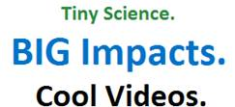  Submit your videos!  Will your research lead to nanotechnologies  that impact our daily lives? Demonstrate  how your work will bring solutions to  real-world problems. This contest is for  graduate students in the United States  and U.S. territories.  SUBMISSIONS  accepted from July 1, 2015  through November 12, 2015.  PUBLIC VOTING  begins November 19, 2015.  For details visit:  http://www.nano.gov/  studentvideocontest  Questions? Email us  Previous winner:   | 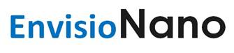  Submit your images!  Help us demonstrate how beautiful the  nanoscale can be and explain how the research behind your picture may lead to  nanotechnologies that benefit society. This  contest is for students in the United States  and U.S. territories.  SUBMISSIONS  accepted from July 1, 2015  through August 26, 2015.  PUBLIC VOTING  begins September 4, 2015.  For details visit:  http://www.nano.gov/  envisionano  Questions? Email us  Previous winner:  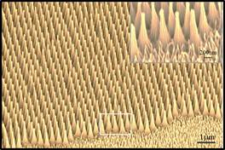
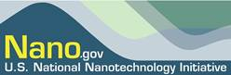
Brought to you by the National Nanotechnology Initiative • www.nano.gov

